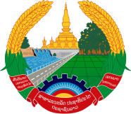
Statement of the Representative of the Lao PDR
At the 35th Session of UPR Working Group
Geneva, 20 - 31 January 2020

Review of Kuwait: 29 January 2020

Mr. President,
Laos would like to extend its congratulation to Kuwait for a remarkable progress made in the promotion and protection of human rights in the country, particularly the enhancement of empowerment of women and rights of children.

In addition, we also commend Kuwait’s efforts in harmonising between the 2030 SDG and its development plans for 2035.

In constructive spirit, Laos wishes to recommend as follows:

- Continue developing training programs in the field of human rights for workers in both public and private sectors; and
- Intensify its efforts to further develop effective measures in the field of human rights, including rights for women, children and persons with disabilities.

We wish Kuwait a very successful UPR.

I thank you, Mr. President.

