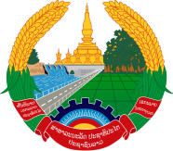

Statement by the Representative of the Lao PDR
At the 35th Session of UPR Working Group
Geneva, 20 - 31 January 2020

Review of Armenia: 23 January 2020

Mr. President,
Laos warmly welcomes the distinguished delegation of Armenia to the UPR session and commends for its comprehensive report presented today.

Laos is pleased to note that the Government of Armenia has made a good progress in implementing the adopted recommendations from the previous cycles of UPR as well as its commitment to further promote and protect human rights in the country, especially the Rights of Child and Rights of Persons with Disabilties.

In constructive spirit, Laos wishes to recommend as follows:

- Continue to allocate adequate budget for the programmes related to children to further develop the system of protection of children rights; and
- Continue to take measures in implementing its Comprehensive Plan for 2017-2021 on Social Inclusion of Persons with Disabilities”.

We wish Armenia every success of its UPR.

I thank you, Mr. President.

