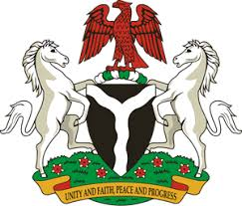
Please check against delivery
HUMAN RIGHTS COUNCIL
35TH SESSION OF THE WORKING GROUP OF THE UPR
REVIEW OF TURKEY
28TH JANUARY, 2020
STATEMENT BY NIGERIA
Madam President,
Nigeria welcomes the delegation of the Republic of Turkey, and commends it for the presentation of the country’s National Report for the Third Cycle UPR. We laud the Government of Turkey for its continued engagement with the UPR process and its commitment to the promotion and protection of human rights, as well as efforts in implementing the previous recommendations.
2. In the spirit of constructive dialogue, Nigeria makes the following recommendations for the consideration of Turkey:
- Continue efforts in combatting human trafficking and ensuring the protection of its victims; and
- Strengthen measures to ensure non-discrimination.
3. Nigeria notes with encouragement, Turkey’s efforts at strengthening its legal and institutional frameworks for the promotion and protection of human rights. We also commend the Government of Turkey for the measures adopted to combat human trafficking and to uphold the rights of victims of human trafficking.
4. In conclusion, we wish Turkey every success in its review process.
I thank you, Madam President.
******

