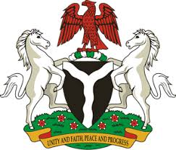
Please check against delivery
HUMAN RIGHTS COUNCIL
35TH SESSION OF THE WORKING GROUP OF THE UPR
REVIEW OF SWEDEN
27TH JANUARY, 2020
STATEMENT BY NIGERIA
Madam President,
Nigeria welcomes the delegation of Sweden to the presentation of the country’s National Report for the Third Cycle of the UPR, and thanks it for the comprehensive update provided today. We commend the Government of Sweden for its commitment to the UPR process and other human rights mechanisms, as well as efforts to implement the previous recommendations.
2. Nigeria takes positive note of measures adopted by the Government of Sweden in combatting discrimination, especially against migrants, and commend its policy of promoting integration of immigrants. We also applaud Sweden’s efforts to combat racism and hate crime, human trafficking and the protection of victims of human trafficking.
3. In the spirit of constructive engagement, Nigeria makes the following recommendations for the consideration of Sweden:
- Scale up efforts in combatting racism, racial discrimination and hate crime; and
- Sustain efforts in combatting human trafficking, and protecting the rights of its victims.
4. Finally, we wish Sweden a very successful review process.
I thank you, Madam President.
******

