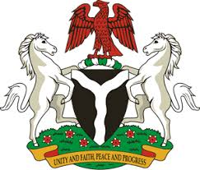
Please check against delivery
HUMAN RIGHTS COUNCIL
35TH SESSION OF THE WORKING GROUP OF THE UPR
REVIEW OF SPAIN
22ND JANUARY, 2020
STATEMENT BY NIGERIA
Mr Vice President,
Nigeria welcomes the delegation of Spain and thanks it for the presentation of its National Report for the Third Cycle UPR. We commend the Government of Spain for its continued cooperation with human rights mechanisms and its efforts in implementing the previous recommendations.
2. Nigeria takes positive note of Spain’s commitment to the promotion and protection of human rights and fundamental freedoms. We applaud the Government of Spain for its effort in combatting racism, racial discrimination and xenophobia, as well as efforts in safeguarding the rights of migrants, refugees and asylum seekers.
3. In the spirit of constructive engagement, Nigeria wishes to make the following recommendations for the consideration of Spain:
- Adopt further measures in safeguarding the rights of migrants, refugees and asylum seekers; and
- Continue efforts in combatting trafficking in persons while ensuring the protection of the rights of its victims.
4. In conclusion, we wish Spain every success in its review.
I thank you, Mr Vice President.
******

