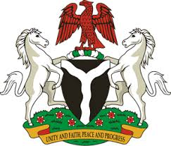
Please check against delivery
HUMAN RIGHTS COUNCIL
35TH SESSION OF THE WORKING GROUP OF THE UPR
REVIEW OF LESOTHO
22ND JANUARY, 2020
STATEMENT BY NIGERIA
Madam President,
Nigeria warmly welcomes the delegation of Lesotho to the presentation of the country’s National Report for the Third Cycle UPR. We take positive note of efforts by the Government of Lesotho towards the implementation of the previous recommendations, as well as its commitment to the UPR process.
2. Nigeria notes with encouragement Lesotho’s efforts at strengthening its legal and institutional frameworks for the promotion and protection of human rights. We commend the Government of Lesotho for its determination to combat corruption and enhance good governance. The measures adopted by Lesotho in fighting human trafficking are also commendable.
3. While acknowledging efforts by the Government of Lesotho in upholding human rights, Nigeria recommend the following to Lesotho:
- Not to relent in its determination to combat corruption and ensure good governance; and
- Sustain efforts in upholding human rights and seek necessary support to enhance its capacity in this regard.
4. In conclusion, we wish Lesotho a very successful review process.
I thank you, Madam President.
******

