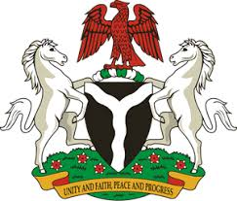
Please check against delivery
HUMAN RIGHTS COUNCIL
35TH SESSION OF THE WORKING GROUP OF THE UPR
REVIEW OF KUWAIT
29TH JANUARY, 2020
STATEMENT BY NIGERIA
Mr Vice President,
Nigeria welcomes the delegation of Kuwait to the presentation of the country’s Third Cycle UPR National Report. We commend the Government of Kuwait for its commitment to the UPR process, and efforts in implementing recommendations it accepted during the previous review.
2. Nigeria takes positive note of efforts by the Government of Kuwait towards the empowerment of women, as well as in strengthening the country’s legal and institutional frameworks in the field of human rights. Also commendable are measures adopted by Kuwait to protect the rights of vulnerable groups in the society.
3. In the spirit of constructive dialogue, Nigeria recommends the following to Kuwait:
- Scale up efforts in the promotion and protection of the rights of migrant and domestic workers; and
- Strengthen measures to combat human trafficking and to protect the rights of its victims.
4. In conclusion, we wish Kuwait a very successful review process.
I thank you, Mr Vice President.
******

