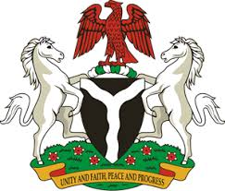
Please check against delivery
HUMAN RIGHTS COUNCIL
35TH SESSION OF THE WORKING GROUP OF THE UPR
REVIEW OF KENYA
23RD JANUARY, 2020
STATEMENT BY NIGERIA
Madam Vice President,
Nigeria warmly welcomes the delegation of the Republic of Kenya and thanks it for the presentation of the country’s National Report for the Third Cycle UPR, as well as the comprehensive update provided today. We commend the Government of Kenya for its efforts in implementing the previous recommendations, and its continued engagement with the UPR process and other human rights mechanism.
2. Nigeria takes positive note of the Government’s efforts to strengthen the country’s judicial system for the promotion of effective and efficient administration of justice. The Government’s efforts in combatting sexual and gender-based violence are commendable. We also applaud Kenya’s efforts in fighting corruption.
3. In the spirit of constructive engagement, Nigeria make the following recommendation for the consideration of Kenya:
- Sustain efforts in the fight against corruption; and
- Continue efforts in combatting human trafficking and child labour.
4. Finally, we wish Kenya a very successful review process.
I thank you, Madam Vice President.
******

