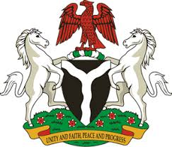
Please check against delivery
HUMAN RIGHTS COUNCIL
35TH SESSION OF THE WORKING GROUP OF THE UPR
REVIEW OF GUYANA
29TH JANUARY, 2020
STATEMENT BY NIGERIA
Madam President,
Nigeria welcomes the delegation of the Co-operative Republic of Guyana and thanks it for the presentation of the country’s National Report for the Third Cycle UPR. We commend the Government of Guyana for its efforts in implementing previous recommendations, and its cooperation with the UPR and other human rights mechanisms.
2. Nigeria takes positive note of measures adopted by the Government of Guyana for the justice and security sector reforms, as well as to combat domestic and sexual violence. The Government’s efforts in the field of health, education and combatting human trafficking are also note-worthy.
3. While recognising the various efforts by Guyana in upholding human rights, and acknowledging the need for further improvement, Nigeria makes the following recommendation for the consideration of Guyana:
- Continue efforts in ensuring an effective and efficient health-care system, as well as access to quality education; and
- Strengthen measures to combat human trafficking.
4. Finally, we wish Guyana a very successful review process.
I thank you, Madam President.
******

