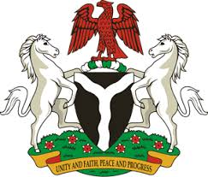
Please check against delivery
HUMAN RIGHTS COUNCIL
35TH SESSION OF THE WORKING GROUP OF THE UPR
REVIEW OF GUINEA-BISSAU
24TH JANUARY, 2020
STATEMENT BY NIGERIA
Madam Vice President,
Nigeria warmly welcomes the delegation of the Republic of Guinea-Bissau to the presentation of the country’s National Report for the Third Cycle UPR. We commend the Government of Guinea-Bissau for the continued cooperation with the UPR process and its efforts in implementing the previous recommendations.
2. Nigeria note with encouragement, efforts by the Government of Guinea-Bissau towards strengthening the country’s legal and institutional frameworks in the field of human rights. We applaud the Government’s efforts in the provision of quality education and increase in school enrolments.
3. While taking cognisance of the Government’s efforts in upholding human rights, and acknowledging the need for further improvement, Nigeria make the following recommendations for the consideration of Guinea-Bissau:
- Continue efforts in ensuring effective and efficient health-care system; and
- Continue to mobilize resources and seek necessary international support to enhance its capacity to promote and protect human rights.
4. Finally, we wish Guinea-Bissau every success in its review process.
I thank you, Madam Vice President.
******

