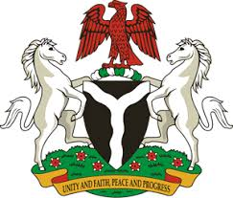
Please check against delivery
HUMAN RIGHTS COUNCIL
35TH SESSION OF THE WORKING GROUP OF THE UPR
REVIEW OF GUINEA
21ST JANUARY, 2020
STATEMENT BY NIGERIA
Madam Vice President,
Nigeria warmly welcomes the delegation of the Republic of Guinea and commends it for the presentation of the country’s National Report for the Third Cycle UPR. We applaud Guinea’s continued engagement with the UPR process, as well as efforts towards the implementation of previous recommendations.
2. Nigeria takes note of the commendable efforts by the Government of Guinea in strengthening the country’s legal and institutional frameworks for the promotion and protection of human rights and fundamental freedoms. We also commend the Government of Guinea for the steps taken towards poverty reduction and job creation, with a view to improving the socio-economic well-being of its people.
3. While acknowledging the many achievements of Guinea in the field of human rights, and in the spirit of constructive dialogue, Nigeria recommends the following for the consideration of Guinea:
- Continue efforts in ensuring an effective and efficient health-care system for the betterment of its people; and
- Continue to mobilize resources and seek necessary support to enhance its capacity for the promotion and protection of human rights.
4. In conclusion, we wish Guinea a very successful review process.
I thank you, Madam Vice President.
******

