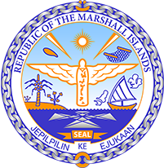
Republic of the Marshall Islands
STATEMENT by Victoria Constance Huang on behalf on the Permanent Mission
UPR 35th session
January 16, 2020 Geneva

GUINEA-BISSAU

Thank you, Madam President.

The Marshall Islands warmly welcomes the delegation of Guinea-Bissau. We thank the delegation for its report and presentation.

We welcome the government’s ratification of the International Convention on the Protection of the Rights of All Migrant Workers and Members of Their Families and the Optional Protocol to the Convention on the Rights of Persons with Disabilities. Through the ratification of these instruments, Guinea-Bissau has advanced the rights of some of the most vulnerable persons and we celebrate this improvement.

Likewise, we are pleased to note that the government has taken critical steps in improving its justice system by providing training for lawyers and judicial decision-makers. Further, the government’s judicial reforms will streamline criminal proceedings, while serving principles of fairness and justice.

We offer the following recommendations for Guinea-Bissau’s consideration:

- Establish and strengthen national policies and institutions that domesticize human rights;
- Implement policies to mitigate the effects of climate change, which already include diminishing rainfall, rising temperatures, and reduced production of staple foods.

Kommol tata and thank you.

