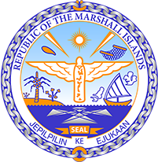
Republic of the Marshall Islands
STATEMENT by Victoria Constance Huang on behalf on the Permanent Mission
UPR 35th session
January 16, 2020 Geneva

GRENADA
Thank you, Madam President.

The Marshall Islands warmly welcomes the delegation of Grenada. We thank the delegation for its report and presentation.

We commend Grenada on its efforts to expand and enhance its Ombudsman office to function as a robust National Human Rights Institution in conformity with the Paris Principles. As the decision to adapt an existing national institution to function as a NHRI follows an extensive and thorough process of consultation, we welcome such a thoughtful acceptance of previous recommendations.

Likewise, we are encouraged by the 2018 establishment of a ministry that will oversee climate resilience measures. Notably, Grenada was the first CARICOM country to approve a National Adaptation Plan as introduced by the UNFCCC.

We offer the following recommendations for Grenada’s consideration:

- Issue open invitations to special procedures mandated by the Human Rights Council, including thematic mandate holders; and
- Introduce a freedom of information law that is in line with international standards.

Kommol tata and thank you.

