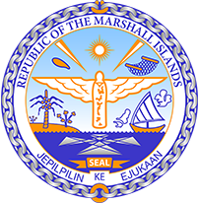
Republic of the Marshall Islands
STATEMENT on behalf on the Permanent Mission
UPR 35th session
January 16, 2020 Geneva

KIRIBATI

Thank you, Madam President.

The Marshall Islands warmly welcomes the delegation of Kiribati. We thank the delegation for its report and presentation.

We are pleased to learn that Kiribati has instituted policies that define and prohibit the harassment of women; prohibit domestic violence against both women and men; prohibit discrimination based on gender; and require equal pay for equal work. We celebrate these measures that improve the rights of women and children in a traditionally patriarchal society.

Likewise, we are encouraged by Kiribati’s demonstrated commitment to mitigating the effects of climate change. We note with appreciation that Kiribati’s approach to climate-change policy has been innovative and multidimensional, with the government focusing on addressing child statelessness in the face of climate change and protecting the industries of communities most affected by climate change.

With respect to follow-up on this UPR, we offer the following recommendations for Kiribati’s consideration:

- Issue a standing invitation to accept all UN Special Procedures;
- Address the human rights impacts of nuclear testing by monitoring, assessing, and responding to continuing rights issues;
- Regarding human trafficking, address gaps within its penal code and further work to address human rights in the fisheries sector; and
- Implement domestic legislation that prohibits child labor.

Kommol tata and thank you.

