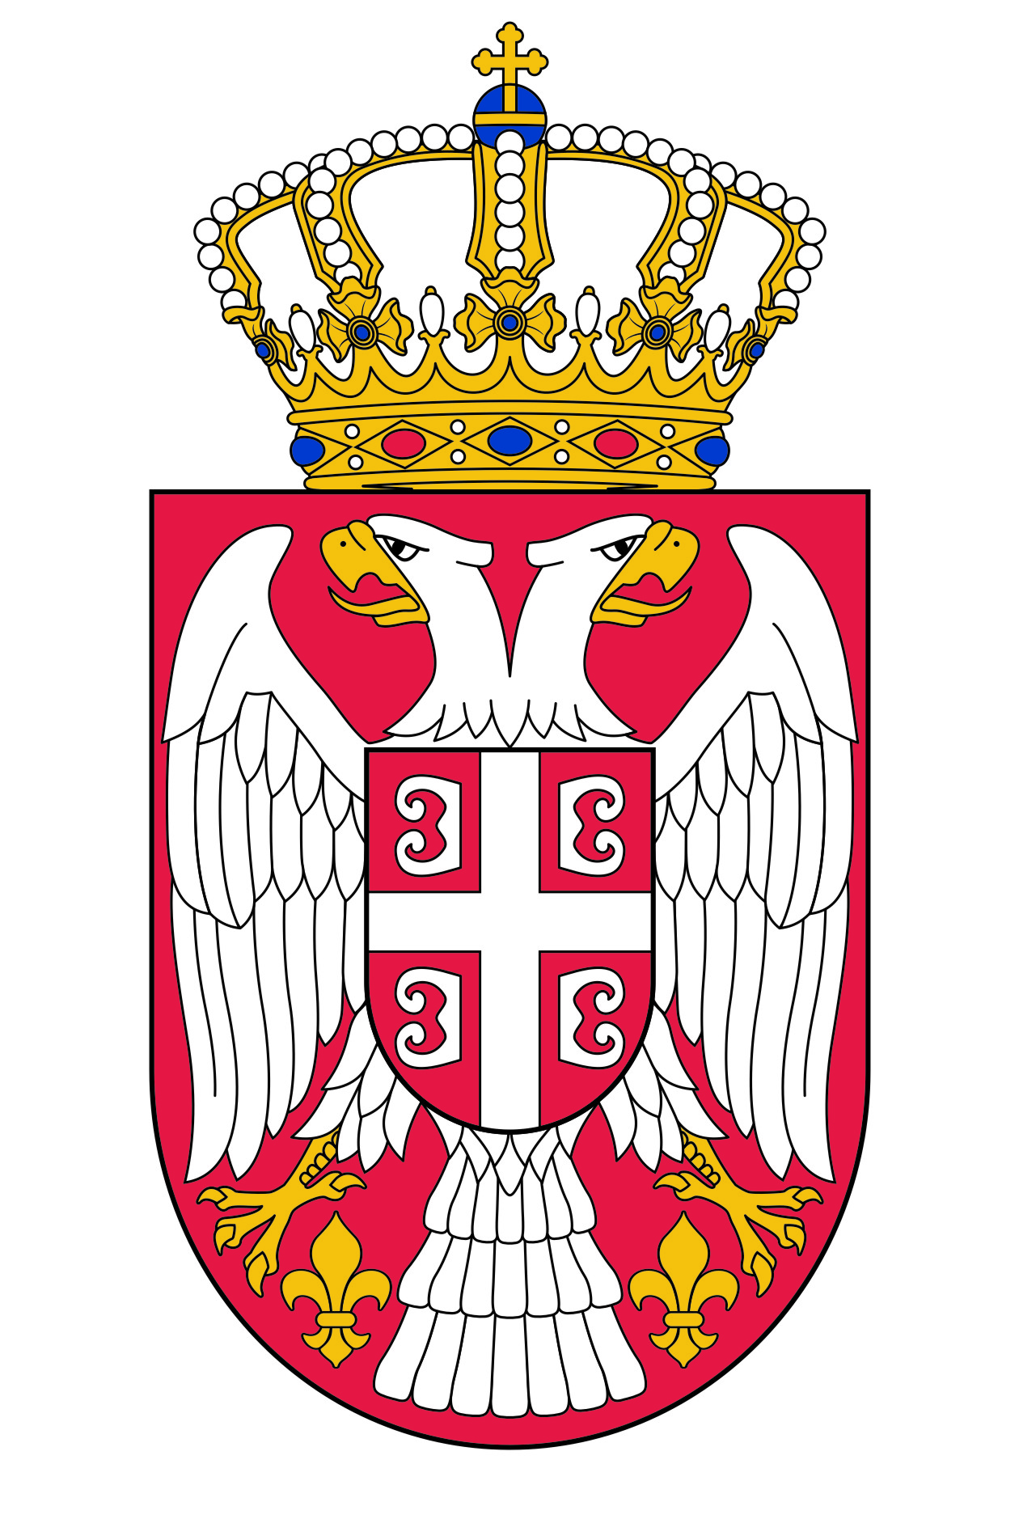

Permanent Mission of the Republic of Serbia to the United Nations Office in Geneva

Working Group for UPR
Interactive Dialogue on Report of Kyrgyzstan
January 2020

The Republic of Serbia welcomes the delegation of Kyrgyzstan and thanks the head of delegation for the comprehensive presentation of the UPR National Report.
The authorities of Kyrgyzstan has shown a genuine commitment to the UPR process. Serbia in particular welcomes the measures on the improvement of the judiciary and the situation of women.
In spirit of a constructive dialogue, we would like to recommend to Kyrgyzstan the following:
- to continue to implement a national strategy to reduce the number of homeless persons,
- to make further efforts in order to eliminate discrimination in access to health services and improve access to maternal health services, taking into account the technical guidelines of the Office of the High Commissioner for Human Rights to reduce and prevent maternal mortality.
We wish Kyrgyzstana fruitful results of the review process.

