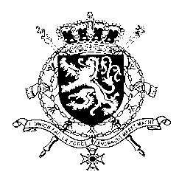
Représentation permanente de la Belgique auprès des Nations Unies et auprès des institutions spécialisées à Genève

WG UPR 35 – Kyrgyzstan
Belgian intervention
20th of January 2020

Madam President,

Belgium thanks the delegation of Kyrgyzstan for the presentation of its national report. We are convinced that further progress can be achieved to increase the protection of human rights in line with the core international human rights treaties.

Belgium therefore recommends the government of Kyrgyzstan to:

R1. Adopt a comprehensive freedom of information law in line with its obligations under Article 19 of the ICCPR.

R2. Ensure that all victims of the 2010 conflict are appropriately compensated, with specific attention to vulnerable groups such as ethnic minorities and in particular women and children.

R3. Ensure sufficient training, follow-up and monitoring to allow the 2016 law on forced marriages of children and the 2017 law on domestic violence to achieve their full effect.

Thank you, Madam President.

