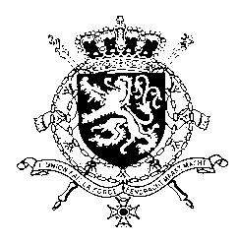
Représentation permanente de la Belgique auprès des Nations Unies et auprès des institutions spécialisées à Genève

WG UPR 35 – Guinea Bissau
Belgian intervention
24th of January 2020

Madam President,

Belgium appreciates Guinea Bissau’s engagement with the UPR and welcomes the efforts to fight impunity in human rights violations. Nevertheless, Belgium remains of the view that there is still room for further progress to protect the vulnerable.

Belgium therefore recommends the government of Guinea Bissau to:

R1. Increase efforts to combat female genital mutilation by developing a clear capacity-building plan for service providers.

R2. Adopt the Code on Child Protection and implement the provisions to protect children from child labour, sexual exploitation and abuse, human trafficking.

As an elementary condition to good governance, economic development and political and social stability, we further recommend to

R3. Scale up the fight against impunity and corruption by taking further steps towards the full implementation of the justice reform.

Thank you, Madam President.

