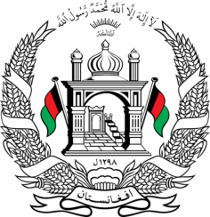
Permanent Mission of Islamic Republic of Afghanistan
35th Session of the UPR Working Group
Statement at the 3rd UPR of Sweden
9:00- 12:30 January 27, 2020
Thank you, Madam President!
Afghanistan welcomes the distinguished delegation of Sweden and thanks them for their national report.
We acknowledge Sweden's international development cooperation and appreciates its adoption of the national plans to combat xenophobia, hate crimes and other forms of intolerance.
We recommend to Sweden the following:
- Ensure that asylum seekers and refugees enjoy their human rights including the right to family reunification.
- Ensure that policies and practices related to the return and expulsion of asylum seekers respect the principle of non-refoulement.
- Continue its efforts to implement existing legislation and take necessary measures to protect vulnerable groups from all forms of hate crimes.
Afghanistan wishes Sweden success in the UPR process.
I thank you, Madam. President!

para 74, UNR.
Para 75, UNR.
Para 15, UNR.

