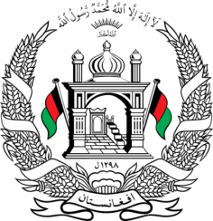
Permanent Mission of Islamic Republic of Afghanistan
35th Session of the UPR Working Group
Statement at the 3rd UPR of Kyrgyzstan
9:00- 12:30 January 20, 2020
Thank you, Mr. President!
Afghanistan welcomes the distinguished delegation of Kyrgyzstan and thanks them for their detailed presentation of the third national report.
My delegation congratulates Kyrgyzstan for adoption of the Action Plan for the implementation of United Nations Security Council Resolution1325 on women, peace and security for the term 2018-2020; and the adoption of the Human Rights Action Plan for 2019- 2021.
Mr. President;
While appreciating Kyrgyzstan’s human rights achievements, my delegation recommends to Kyrgyzstan the followings:
- Take appropriate measures to provide access to quality, multilingual and inclusive education for children especially for the children with disabilities and minorities.
- Adopt a comprehensive strategy for gender equality in the area of economic, social and cultural rights and ensure integration of a gender perspective into the post-2015 development framework.
Afghanistan wishes Kyrgyzstan success in this cycle of the UPR review process.
I thank you, Mr. President!

