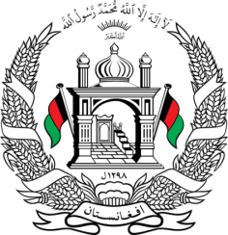
Permanent Mission of Islamic Republic of Afghanistan
35th Session of the UPR Working Group
Statement at the 3rd UPR of Kuwait
January 29, 2020
Mr. Vice President!
Afghanistan welcomes the distinguished delegation of Kuwait.
We welcome the enforcemnt of Domstic Workers Act, its provisions on rights and obligations of workers and employers and all other refroms aligned with ILO conventions. We also commend Kuwait’s cooperation since its last UPR review to the Threaty Bodies and Special Procedures.
We recommends the following:
1- Ratifiy the Optional Protocol to the Convention Against Torture,
2- Take measure that grants workers the appropriate rights including the freedom to change employers and leave the country,
3- Introduce a legislation to regulate asylum proceedings in accordance with international law.
Finally, Afghanistan wishes Kuwait a successful review.
Thank you Mr. V President

