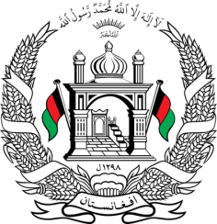
Permanent Mission of Islamic Republic of Afghanistan
35th Session of the UPR Working Group
Statement at the 3rd UPR of Kenya
January 23, 2019
Madam vice-President!
Afghanistan cordially welcomes the distinguished Kenyan delegation.
We welcome the positive developments since the previous cycle such as the adoption of the National Policy and Action Plan on Human Rights, the establishment of small claims courts and the allocation of substantial budget to help persons with albinism.
Nevertheless, attacks on persons with albinism, incidents of violence against women and children and the prevalence of harmful cultural practices, remains a matter of concern.
In view of the above, and in a constructive manner, my delegation wishes to make the following recommendations:
- Continue to adopt measures to address poverty in the light of Vision 2030 and the SDGs.
- Continue to prosecute acts of racial discrimination and hate speech and adopt a comprehensive strategy to eliminate harmful cultural practices.
- Ensure the protection of asylum seekers and refugees in its territory, provide adequate food and health services in reception facilities with the help of the international Community.
Finally, Afghanistan wishes Kenya a successful review.
I Thank you

