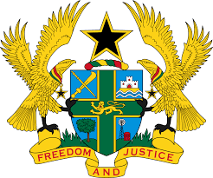

STATEMENT BY GHANA DELIVERED BY ABA AYEBI-ARTHUR,
COUNSELLOR, TUESDAY 28TH JANUARY, 2020

REVIEW OF TURKEY

Thank you, Mr. President,
Ghana welcomes the delegation of Turkey to the UPR Working Group.
We commend the progress made by Turkey in the last couple of years to promote and protect human rights and the principle of rule of law. We note in particular the constitutional amendment in 2017 which provides stronger mechanism on the principle of separation of powers and the ratification of the Optional Protocol to the Convention on the Rights of Persons with Disabilities.

Ghana wishes to make the following two recommendations:
- Consider to ratify the outstanding core International human rights treaties and convention. Of note is the Convention on the Protection of the Rights of All Migrants Workers and Members of their Families and;
- Continue efforts to eliminate acts of torture and ill treatments and hold the perpetrators accountable.

Ghana wishes Turkey every success with the review process.

I thank you.

