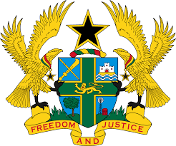

STATEMENT BY GHANA DELIVERED BY MS. ABA AYEBI-ARTHUR, COUNSELLOR, MONDAY, 27TH JANUARY 2020

REVIEW OF SWEDEN

Thank you, Mr. President
Ghana welcomes the delegation of Sweden to the UPR Working Group.
We note with appreciation additional steps taken by the Government since the last UPR to promote and protect human rights, such as measures to combat racism and hate crime, segregation and promotion of integration of newly arrived immigrants as well as the establishment of an independent National Human Rights Institution in 2018.

Our recommendations:
- Consider ratifying the International Convention on the Protection of the Rights of All Migrants Workers and Members of their families at the earliest convenience and;

- Continue efforts to eliminate hate crimes, including racist and xenophobic crimes and bring perpetrators accountable.

We wish the delegation of Spain every success with this UPR process.

I thank you.

