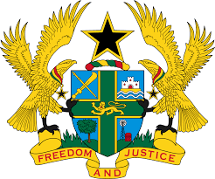

STATEMENT BY GHANA DELIVERED BY ABA AYEBI-ARTHUR,
COUNSELLOR, WEDNESDAY, 22ND JANUARY, 2020

REVIEW OF LESOTHO

Thank you, Mr. President

Ghana warmly welcomes the delegation of Lesotho to the UPR Working Group.

My delegation commends the government for their commitment to upholding the rule of law, promotion of gender equality, empowerment of women, combatting of human trafficking as well as promotion and protection of the rights of children. We also note with appreciation the establishment of a National Anti-Corruption Strategy and Action Plan for 2014/15 to 2018/19.

Ghana wishes to make the following three recommendations:
- Consider to ratify the outstanding core International human rights treaties and convention, including the Optional Protocol to the Convention against Torture and other cruel, inhuman or Degrading Treatment or Punishment;

- Consider to take measures to investigate all cases of torture and other inhuman and degrading treatments and punish the perpetrators accordingly and;

- Continue to strengthen efforts to prevent and combat the abuse of children, including domestic and sexual exploitation and abuse.

Ghana wishes Lesotho every success with the UPR process.

I thank you.

