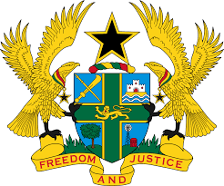

STATEMENT BY GHANA DELIVERED BY MS. ABA AYEBI-ARTHUR,
COUNSELLOR, WEDNESDAY 22ND JANUARY, 2020

REVIEW OF SPAIN

Thank you, Mr. President
Ghana extends a warm welcome to the delegation of Spain to the UPR Working Group.
We commend the establishment of a National Human Rights Bureau of the National Police established in 2019 and also note with appreciation the progress made since the adoption of the Action Plan for the Implementation of the 2030 Agenda for Sustainable Development in June, 2018.
In the spirit of constructive dialogue, we recommend the following:

- Continue with the on-going efforts to ensure the improvement of the current arrangements in detention and deportation of irregular migrants in accordance with International best practices;

- Take steps to ensure the respect of the rights of freedom of expression and association, particularly regarding the Catalonia region and finally;

- Continue efforts to combat hate crime and put measures in place to ensure an end to ethic and racial profiling and all forms of racial discrimination.
Ghana wishes Spain a successful review outcome.

I thank you.

