Check against delivery: One (1) Minute and Twenty (20) Seconds

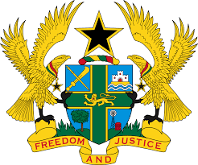
STATEMENT BY GHANA DELIVERED BY ABA AYEBI-ARTHUR,
COUNSELLOR, TUESDAY 21ST JANUARY, 2020

REVIEW OF GUINEA

Thank you, Mr. President,
Ghana joins other delegations to welcome the delegation of Guinea to the UPR Working Group.
We commend the Government of Guinea for the signing and ratification of a number of Human Right instruments, particularly the Convention on the Elimination of All Forms of Discrimination against Woman and the Convention on the Rights of the Child. My delegation further welcomes Guinea in its efforts to ensure the promotion and protection of human rights in the country, particularly the establishment of new institutions which include the Independent National Human Rights Institution and the Ministry of Citizenship and National Unit responsible for human rights issues.
To further strengthen human rights promotion in Guinea we wish to make the following recommendations:
- Continue with the on-going efforts to ratify the Optional Protocol to the Convention against Torture and Other Cruel, Inhuman and Degrading Treatment or Punishment;
- Encourage to strengthen the functioning and independence of the National institution for Human Rights to guarantee its compliance with the Paris Principle and lastly;
- Continue to enact and fully implement legislations that seek to promote and protect the rights to freedom of expression, association and information.

Ghana wishes Guinea every success in this review process.

I thank you.

