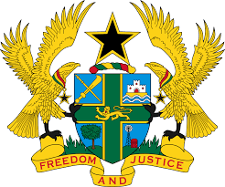

STATEMENT BY GHANA DELIVERED BY ABA AYEBI-ARTHUR,
COUNSELLOR, WEDNESDAY 29TH JANUARY 2020

REVIEW OF KUWAIT

Thank you, Mr. President,
Ghana welcomes the delegation of Kuwait to the UPR Working Group.
We commend the progress made by Kuwait in implementing several recommendations accepted during the second Cycle of the UPR, in particular the creation of a human rights departments in the Ministry of Foreign Affairs and the family insurance fund within the Ministry of Justice.
Ghana recommends Kuwait to:
- Ensure that the ongoing review of domestic laws guarantees gender equality and the rights of women and girls;
- Take steps to ensure the full implementation of the Private Sector Employment Act N0. 6 of 2010 to ensure the protection of migrants and foreign workers and;
- Consider ratifying the Optional Protocol to the Convention against Torture and Other Cruel, Inhuman or Degrading Treatment or Punishment (OP-CAT) at the earliest convenience.

We wish Kuwait every success with the review process.

I thank you.

