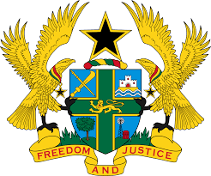

STATEMENT BY GHANA DELIVERED BY ABA AYEBI-ARTHUR,
COUNSELLOR, FRIDAY 24TH JANUARY, 2020

REVIEW OF THE GUINEA-BISSAU

Thank you, Madam Vice -President,
Ghana extends a warm welcome to the distinguished delegation of Guinea-Bissau to the UPR Working Group.

We commend the progress made in the last couple of years to promote and protect human rights and fundamental freedoms albeit some challenges faced by the country. We note in, particular, the ratification of the Optional Protocol to the Convention on the Rights of Persons with Disability and the International Convention on the Protection of the Rights of All Migrant Workers and Members of their Families.
Ghana wishes to make the following recommendations:
- Consider ratifying the Optional Protocol to the Convention against Torture and other cruel, inhuman or Degrading Treatment or Punishment;

- Continue with the ongoing review of domestic laws to promote children and human rights practice and hold all perpetrators accountable;

- Continue efforts to strengthen the Judicial Service and consider allocating adequate resources to the sector and lastly;

- Continue the efforts in promoting the rights of women and children, in particularly to reestablish the Ministry of Women’s Affairs which was abolished in March, 2019.

Ghana wishes Guinea-Bissau a successful UPR outcome.

I thank you.

