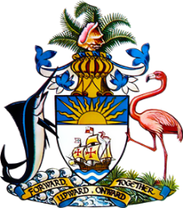

Statement by Mr. Frank Davis, Chargé d’affaires, a.i.
Permanent Mission of The Bahamas to the United Nations Office and Other International Organisations in Geneva
at the 35th Session of the Universal Periodic Review Working Group
Presentation of UPR Report by the Government of Guyana
29 January 2020

Thank you, Mr. President.
The Bahamas extends a warm welcome to the sister CARICOM delegation of Guyana and we commend the country for both its achievements in the sphere of human rights and its commitment to the UPR Process.
In a constructive spirit, The Bahamas recommends that Guyana:

- Strengthen efforts to address rates of maternal mortality, including through provision of increased access to primary healthcare and community-based services for pregnant women, including in remote reas;
- continue reforms in labour laws to establish a national minimum wage and offer protections against disparities in pay based on gender and race;

- undertake initiatives to combat child marriages, including through improving economic and social conditions that buttress their proliferation, and undertake a robust public education campaign to reduce the number of minors married with judicial authorization annually; and
- continue efforts to combat all forms of racial discrimination, particularly against indigenous populations and persons of African descent.

We congratulate Guyana in its efforts to promote and protect human rights and commend the articulation of the Green State Development Strategy 2040, which seeks to address key development challenges in a systematic and comprehensive manner. As a fellow CARICOM and developing State, The Bahamas is keenly aware of the challenges faced including as a result of climate change. We therefore encourage Guyana to continue pursuing positive mitigation, and adaptation efforts.
We wish Guyana a successful UPR.

I thank you.

