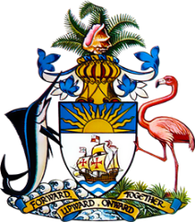

Statement by Mr. Frank Davis, Chargé d’affaires a.i.
Permanent Mission of The Bahamas to the United Nations Office and Other International Organizations in Geneva
at the 35th Session of the Universal Periodic Review Working Group
Review of The Republic of Turkey
Tuesday, 28th January, 2020

Thank you [Mr/Madame] [Vice] President.
The Bahamas extends a warm welcome to the delegation of The Republic of Turkey.
We commend Turkey’s commitment to the promotion and protection of human rights including its efforts to advance the rights of persons with disabilities, women’s rights, and freedom of religion and expression.
In a constructive spirit, The Bahamas recommends that Turkey:
- Addresses root causes of pervasive underreporting of gender-based violence and undertakes concrete efforts to encourage reporting, including through the provision of adequate resources for this purpose
- Increases efforts to combat Trafficking in Persons, particularly among vulnerable groups such as migrants
- Ratifies the Paris Climate Agreement and ensures the mainstreaming of gender equality in its implementation
We commend the provisions implemented to prevent all forms of discrimination against women, seen in the country’s 10th and 11th Development Plan, in The Strategy Paper and Action Plan on Women’s Empowerment and in the Third National Action Plan on Combating Violence Against Women.
The Bahamas wishes Turkey every success in this UPR process.

Thank you.

