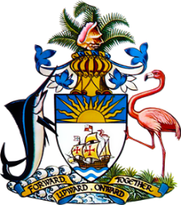

Statement by Mr. Frank Davis, Chargé d’affaires, a.i.
Permanent Mission of The Bahamas to the United Nations Office and Other International Organizations in Geneva
at the 35th Session of the Universal Periodic Review Working Group
Presentation of National Report by the Government of Sweden
Monday 27th January, 2020

Thank you, Madam/Mr. [Vice] President.
The Bahamas extends a warm welcome to the delegation of Sweden and thanks the country for its report.
The Bahamas submits the following recommendations to Sweden:

- Continue efforts to establish a National Human Rights Institution in compliance with the Paris Principles;
- Strengthen enforcement of the Discrimination Act, including through adequate oversight and appropriate sanctions for non-compliance and promote public awareness of the Act’s provisions; and
- Fully implement the National Plan to Combat Racism

We commend Sweden for the work it has done in promoting and protecting human rights, including its recent incorporation of the Convention of the Rights of the Child (CRC) into Swedish law. We also welcome the establishment of the Swedish Gender Equality Agency.

We wish the delegation every success in this UPR process.

I thank you.

