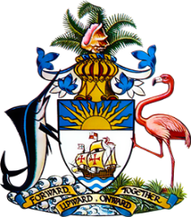

Statement by Ms. Sasha Dixon, Second Secretary
Permanent Mission of The Bahamas to the United Nations Office and Other International Organizations in Geneva
at the 35th Session of the Universal Periodic Review Working Group
Presentation of National Report by the Government of Armenia
23 January, 2020

Thank you, Madam/Mr. [Vice] President.
The Bahamas extends a warm welcome to the delegation of Armenia and congratulates the country for its ongoing efforts in the promotion and protection of human rights.
With a view to encouraging further progress, The Bahamas respectfully recommends that Armenia:
- Fully implements the anti-corruption strategy (2019-2022)
- Conducts broad public education and awareness with a view to combatting hate speech, stereotypes and discrimination
- Continues efforts to combat trafficking in persons by fully implementing its existing laws, plans and programmes to that effect
We commend actions taken by Armenia in a number of areas, including in the fight against human trafficking, particularly through the enactment of new legislation, and welcome the strengthening of the Human Rights Defenders mandate. Moreover, we congratulate Armenia’s Human Rights Defenders on being re-accredited with “A” status by the Sub-Committee on Accreditation of the Global Alliance of National Human Rights Institutions.
We wish Armenia every success in this UPR process.
I thank you.

