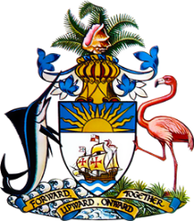

Statement by Ms. Sasha Dixon, Second Secretary
Permanent Mission of The Bahamas to the United Nations Office and Other International Organizations in Geneva
at the 35th Session of the Universal Periodic Review Working Group
Presentation of National Report by the Government of Lesotho
22 January, 2020

Thank you, Madam/ Mr. [Vice] President.

The Bahamas extends a warm welcome to the delegation of Lesotho.

We thank Lesotho for its candid national report, which benefitted from an inclusive consultation process and we congratulate the country on its continued dedication to the UPR process. With a view to promoting further advancement in the field of human rights, The Bahamas respectfully recommends that Lesotho:

- Prioritizes the guarantee of access to water and sanitation to schools at all levels, including pre-schools and day care centres as well as in rural areas
- Adopts national anti-torture legislation to ensure full implementation of the Convention Against Torture (CAT)
- Amends or repeals article 18 (4)(c) of their constitution in order to protect women and persons with disabilities from discrimination

Furthermore, we wish to congratulate Lesotho on the significant efforts invested in the overall promotion of human rights, despite challenges faced, such as vulnerability to droughts due to the effects of climate change. Particularly in the area of education, we commend Lesotho as one of the world leaders in public expenditure on education, with at least 9% of its Gross Domestic Product dedicated to education. While more work remains to ensure commensurate educational outcomes, we trust that this investment will advance Lesotho closer to achieving universal access to education. Lastly, we commend Lesotho for their initiative to begin the establishment of a National Mechanism for Implementation, Reporting, and Follow-up (NMIRF).

We wish Lesotho every success in this UPR process.

I thank you.

