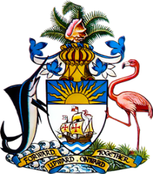

Statement by Mr. Frank Davis, Chargé d’affaires, ai
Permanent Mission of The Bahamas to the United Nations Office and Other International Organizations in Geneva
at the 35th Session of the Universal Periodic Review Working Group
Presentation of National Report by the Government of Spain
22 January, 2020

Thank you, Madam/Mr. [Vice] President.
The Bahamas extends a warm welcome to the delegation of Spain and thanks the country for its comprehensive and inclusive national report.
In a constructive spirit, The Bahamas submits the following recommendations to Spain:

- Take concrete steps to improve access to health and education services by people living in sparsely populated areas;
- Adopt a strategy to reduce high dropout rates and segregation in secondary schools, particularly targeting disadvantaged groups including migrant populations and People of African Descent;

We congratulate Spain for strides made, including in implementing its National Strategy for the Elimination of Violence against Women (2013-2016), adopting the National Covenant on Combating Gender-based Violence (2018-2022) as well as in seeking to protect the rights of persons with disabilities and in adopting its Strategic Framework for Energy and Climate.

We wish the delegation every success in this UPR process.

I thank you.

