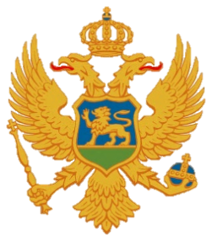

Statement of Montenegro
UPR 3rd cycle, Review of Sweden,
Geneva, 27 January 2020

Montenegro welcomes the distinguished delegation of Sweden and thanks for the presentation of its national report.

We welcome strong legal and institutional protection of human rights in Sweden and commend the high rate of representation of women in political and public life.

We note concerns that the existing anti-discrimination laws and regulations need to be enhanced to afford protection against all forms of discrimination and did not cover discrimination in all areas of public life.

Montenegro recommends the following:
1) to complete the establishment of a national human rights institution;
2) to continue efforts to combat violence against all women.

I thank you.

