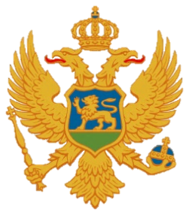

Statement of Montenegro
UPR 3rd cycle, Review of the Kingdom of Spain,
Geneva, 22 January 2020

Madam President,
Montenegro warmly welcomes the distinguished delegation of the Kingdom of Spain.
We praise the legal reforms under which the minimum age for marriage was raised to 16 and those that enable the children of victims of gender-based and other forms of violence to the benefits to which orphans are entitled, as the way to improve their situation. We welcome the ongoing work on a draft bill for the comprehensive protection of children and adolescents from any violence.
While noting challenges regarding the full inclusion of members of Roma communities we welcome steps towards their elimination, in particular regarding the education and training that lead to easier integration in the labor market.
Montenegro recommends:
1. to ensure the accessibility and availability of health-care services for all persons with disabilities;
2. to renew a Strategic Plan on Equal Opportunities as important gender equality tool.

I thank you.

