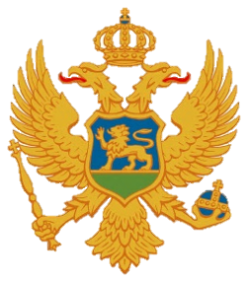

Statement of Montenegro
UPR 3rd cycle, Review of Lao People's Democratic Republic,
Geneva, 21 January 2020

Madam President,
Montenegro welcomes the distinguished delegation of the Lao People's Democratic Republic.
We commend all results that have been achieved in the promotion of human rights. We encourage the national authorities for further engagement, conscious of all objective difficulties, including the economic development, challenges related to rural and remote areas, contamination with ERW and others.
We note with appreciation the adoption of the National Action Plan on the Prevention and Elimination of Violence against Women and Children. We welcome the significant progress that has been made concerning maternal and infant mortality. We encourage the Government to provide equal access for women and men to HIV/AIDS prevention and adequate treatment resources, as well as free access to antiretroviral medicines for women and girls.
We express concern about the lack of a legal framework to define and criminalize all acts of enforced disappearance, the fact that the death penalty still exists, and the reports that victims of human rights violations who have limited education and were poor, faced greater barriers in accessing the formal justice system.
Montenegro recommends:
1) to ratify the International Convention for the Protection of All Persons from Enforced Disappearance;
2) issuing a standing invitation to all special procedures of the HRC.

I thank you.

