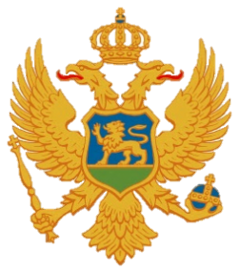

Statement of Montenegro
UPR 3rd cycle, Review of Kiribati,
Geneva, 20 January 2020

Montenegro welcomes the distinguished delegation of Kiribati and thanks for the presentation of its national report.
We welcome the efforts that have been undertaken by the state authorities and achieved results. Being conscious of all objective difficulties that Kiribati is facing with, including the size of its state administration, its geographic position, exposure to natural hazards and consequences of climate change, we encourage the Government to use all available support of the OHCHR and other international partners to enhance the level of implementation of human rights obligations, adopt more comprehensive national legislation and improve its institutional framework and capacity. We note only few core human rights instruments that have been ratified so far and recognize the necessity for more active engagement in that direction.
We express our serious concern regarding the high level of gender-based, domestic and sexual violence, early pregnancies, gender inequality and very low level of participation of women in public and political life due to cultural and social norms.
Montenegro recommends the following:
1) to enact legislation covering all forms of violence against women;
2) to ratify the Convention against Torture and Other Cruel, Inhuman or Degrading Treatment or Punishment and its Optional Protocol.

I thank you.

