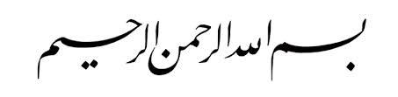

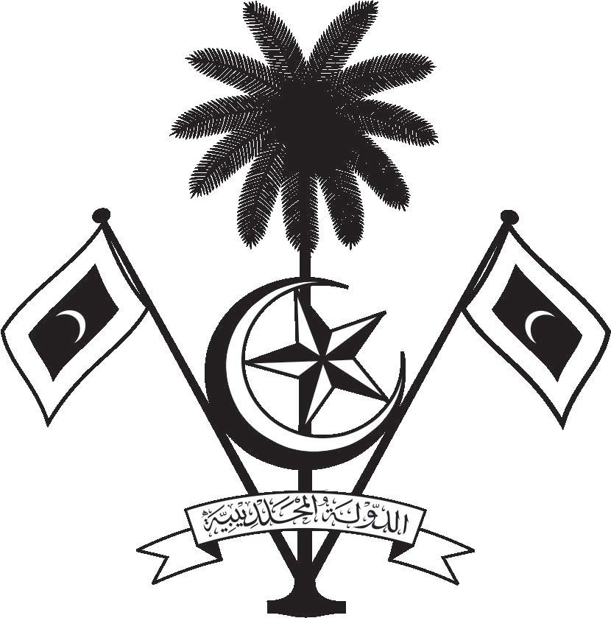

އ.ދ.ގެ ޖެނީވާ އޮފީހާއި ޖެނީވާގައި ހުންނަ ބައިނަލްއަޤްވާމީ ޖަމިއްޔާތަކަށް ކަނޑައަޅާފައިވާ ދިވެހިރާއްޖޭގެ ދާއިމީ މިޝަން
PERMANENT MISSION OF THE REPUBLIC OF MALDIVES TO THE UNITED NATIONS OFFICE
AND OTHER INTERNATIONAL ORGANISATIONS AT GENEVA

35th Session of the Working Group of the Universal Periodic Review
20 -31 January 2020, Geneva
Review of Turkey
28 January 2020
Statement by:
Ambassador Hala Hameed, Permanent Representative

Check against delivery
Thank you, Madam President,

The Maldives warmly welcomes the high-level delegation of Turkey to this third cycle review. We thank the delegation for their presentation today.

In constructive spirit, the Maldives presents the following two recommendations to the Government of Turkey:
1. To strengthen efforts to bring national legislation on defamation and countering terrorism in line with international standards.
2. To ensure effective implementation of the “Strategy Document and National Action Plan on Combating Early and Forced Marriage.”

The Maldives welcomes Turkey’s recent launch of Judicial Reform Strategy to strengthen the rule of law and respect for human rights.

We wish Turkey every success at this review.

Thank you, Madam President.

