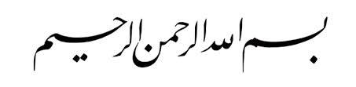

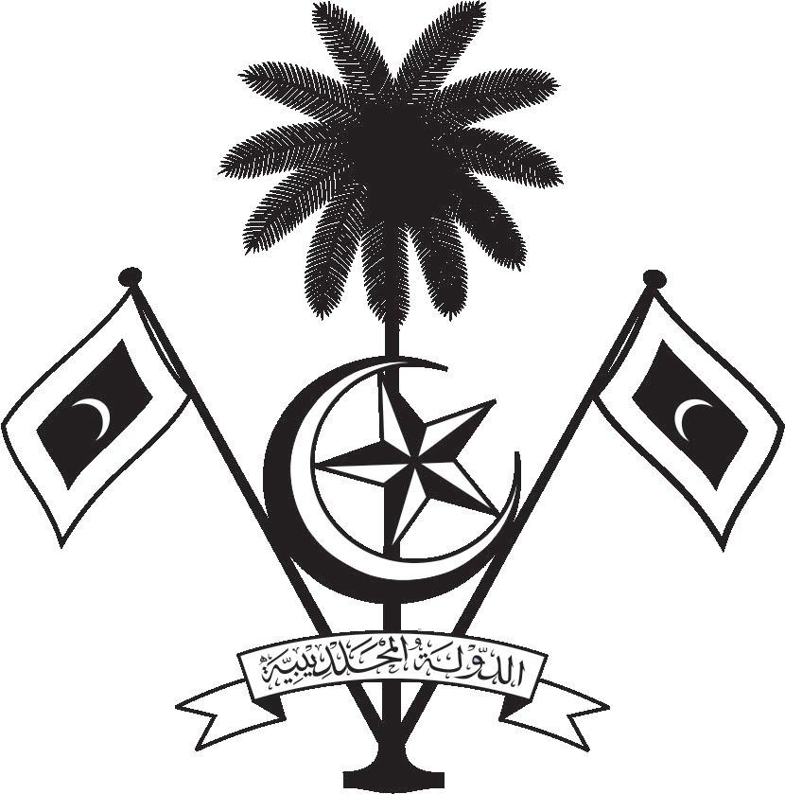

އ.ދ.ގެ ޖެނީވާ އޮފީހާއި ޖެނީވާގައި ހުންނަ ބައިނަލްއަޤްވާމީ ޖަމިއްޔާތަކަށް ކަނޑައަޅާފައިވާ ދިވެހިރާއްޖޭގެ ދާއިމީ މިޝަން
PERMANENT MISSION OF THE REPUBLIC OF MALDIVES TO THE UNITED NATIONS OFFICE
AND OTHER INTERNATIONAL ORGANISATIONS AT GENEVA

35th Session of the Working Group of the Universal Periodic Review
20 -31 January 2020, Geneva

Review of Grenada
27 January 2020
Statement by:
Hawla Ahmed Didi, Deputy Permanent Representative

Check against delivery
Thank you, Mr. Vice President,

The Maldives warmly welcomes the Minister of Foreign Affairs and his delegation to this third cycle review and thanks the delegation for their presentation, and the priority accorded by the government to work with the Contact Group on Council Membership.

The Maldives congratulates the Government of Grenada on its achievements in closing the gender gap in leadership and administrative positions held by women, including the 47 percent of women in parliament. As a Small Island Developing State, we are also encouraged by Grenada’s efforts in addressing issues of climate change and the environment.

In constructive spirit, the Maldives presents the following two recommendations to Grenada:
- To introduce a freedom of information law that is in line with international standards.
- To continue strengthening its efforts in addressing Gender Based Violence, including for people with disabilities.

We wish the delegation of Grenada every success at this review.
Thank you, Mr. Vice President.

