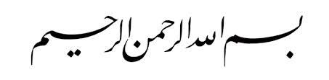

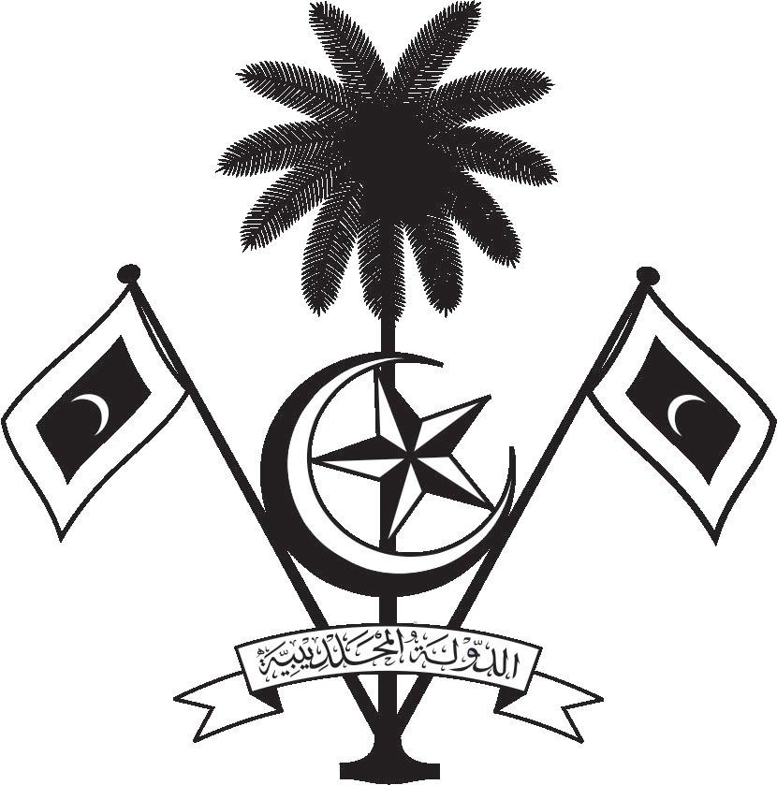

އ.ދ.ގެ ޖެނީވާ އޮފީހާއި ޖެނީވާގައި ހުންނަ ބައިނަލްއަޤްވާމީ ޖަމިއްޔާތަކަށް ކަނޑައަޅާފައިވާ ދިވެހިރާއްޖޭގެ ދާއިމީ މިޝަން
PERMANENT MISSION OF THE REPUBLIC OF MALDIVES TO THE UNITED NATIONS OFFICE
AND OTHER INTERNATIONAL ORGANISATIONS AT GENEVA

35th Session of the Working Group of the Universal Periodic Review
20 -31 January 2020, Geneva
Review of Sweden
27 January 2020
Statement by:
Ambassador Hala Hameed, Permanent Representative

Check against delivery
Thank you, Madam President,

The Maldives warmly welcomes the high-level delegation of Sweden to this third cycle review and thank the delegation for their presentation today.

In constructive spirit, the Maldives presents the following two recommendations to the Government of Sweden:
1. Expedite efforts to establish an independent institution for the protection of human rights.
2. Step up efforts to improve the health status of children from disadvantaged and marginalized groups and allocate sufficient resources to guarantee their right to health, without discrimination.

The Maldives welcomes the new strategy adopted by the Swedish International Development Cooperation Agency for development cooperation in the areas of human rights, democracy and the rule of law for the period 2018–2022.

We wish Sweden a successful review.

Thank you, Madam President.

