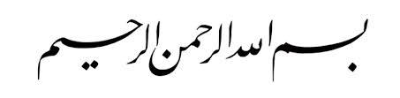

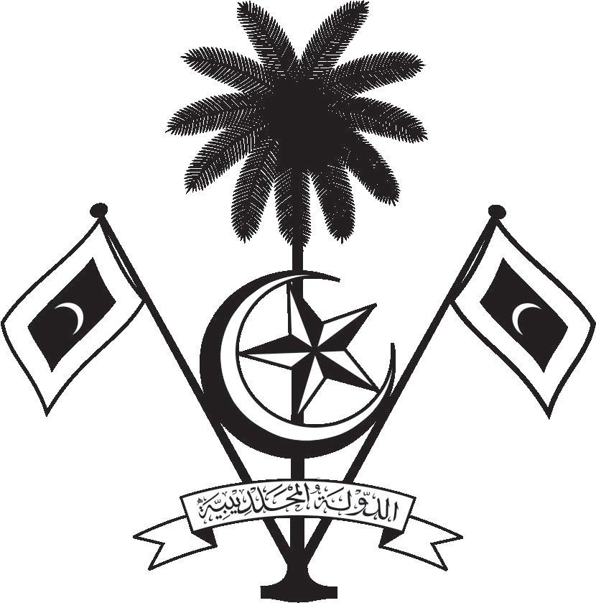

އ.ދ.ގެ ޖެނީވާ އޮފީހާއި ޖެނީވާގައި ހުންނަ ބައިނަލްއަޤްވާމީ ޖަމިއްޔާތަކަށް ކަނޑައަޅާފައިވާ ދިވެހިރާއްޖޭގެ ދާއިމީ މިޝަން
PERMANENT MISSION OF THE REPUBLIC OF MALDIVES TO THE UNITED NATIONS OFFICE
AND OTHER INTERNATIONAL ORGANISATIONS AT GENEVA

35th Session of the Working Group of the Universal Periodic Review
20-31 January 2020, Geneva
Review of Lao PDR
21 January 2020

Statement by:
Ambassador Hala Hameed, Permanent Representative

Check against delivery
Thank you, Madam President,

The Maldives warmly welcomes the high-level delegation of the Lao People’s Democratic Republic to this third cycle review and thanks the delegation for their presentation today.

The Maldives commends the work of the Government of Lao PDR, for all the efforts and measures taken to raise awareness on the country’s constitution by allowing the people of Lao to access legal information through the use of the latest technology.

In constructive spirit, the Maldives presents the following two recommendations to the Government of Lao PDR:
- To review the government’s economic strategy and take necessary steps to conserve the environment by developing guidelines to conduct studies on the environmental impacts of foreign investment projects.

- Establish an independent body to investigate deaths and enforced disappearances of the country and provide this body the investigative powers by law that is necessary to conduct free, independent and reliable investigations.

We wish Lao PDR every success at this Review. Thank you, Madam President.

