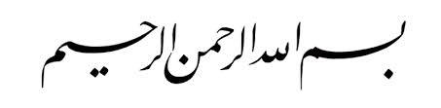

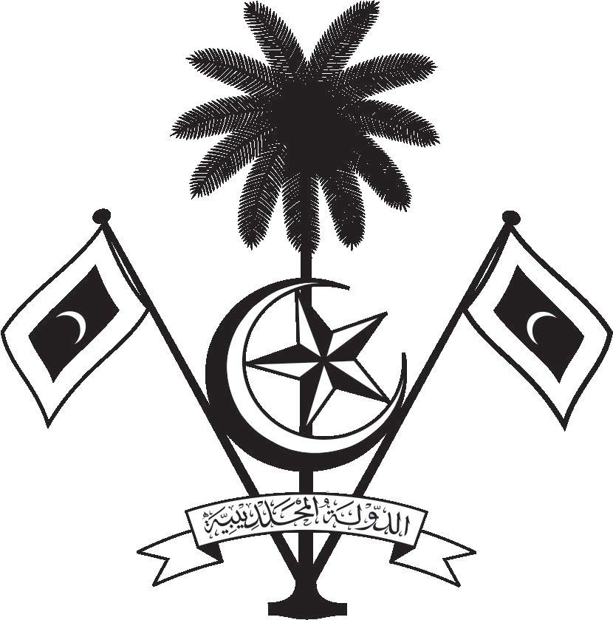

އ.ދ.ގެ ޖެނީވާ އޮފީހާއި ޖެނީވާގައި ހުންނަ ބައިނަލްއަޤްވާމީ ޖަމިއްޔާތަކަށް ކަނޑައަޅާފައިވާ ދިވެހިރާއްޖޭގެ ދާއިމީ މިޝަން
PERMANENT MISSION OF THE REPUBLIC OF MALDIVES TO THE UNITED NATIONS OFFICE
AND OTHER INTERNATIONAL ORGANISATIONS AT GENEVA

35th Session of the Working Group of the Universal Periodic Review
20 -31 January 2020, Geneva
Review of Guinea
21 January 2020
Statement by:
Hawla Ahmed Didi, Deputy Permanent Representative

Check against delivery
Thank you, Madam. Vice President,

The Maldives warmly welcomes the delegation from Guinea to this third cycle review and express our appreciation for today’s presentation and national report.

In constructive spirit, the Maldives presents the following two recommendations to Guinea:
1. To further strengthen their efforts to combat human trafficking and people smuggling.
2. To review the legislation that curbed freedom of expression and to de-criminalize defamation.

The Maldives also wishes to commend the Government of Guinea for its efforts to strengthen the education system in its stride to implement the national poverty reduction strategy. We welcome the national gender policy, which was revised in 2018, and believe this is a strong step towards promoting equality and equity.

We wish the delegation of Guinea every success during this review.
Thank you, Madam. Vice President.

