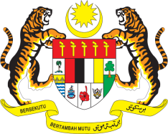

STATEMENT BY MALAYSIA
REVIEW OF KIRIBATI
35TH SESSION OF THE UPR WORKING GROUP
20-31 JANUARY 2020

Mr. Vice President,

Malaysia welcomes the delegation of Kiribati and thanks them for the presentation of their national report.

- We commend Kiribati’s commitment to the UPR and human rights promotion and protection despite facing challenges. Measures taken to promote health care services for women are commendable. Among others, we note that maternal mortality had dropped significantly due to an increase in skilled birth attendants. We hope that Kiribati will continue to strengthen measures to ensure equal access to health services

- In the spirit of constructive engagement, my delegation recommends the following:

3.1. Incorporate a comprehensive approach to sexual and reproductive health into the next National Development Plan for 2021 – 2025, including family planning programs that are accessible to all, and allocate sufficient resources in the annual budget to ensure effective delivery; and

3.2. Revise the Family Life Education curriculum to bring it in line with international guidelines and best practices and integrate it into all school curriculums.

We wish Kiribati a successful review.

I thank you Mr. Vice President.

GENEVA
28 January 2020

