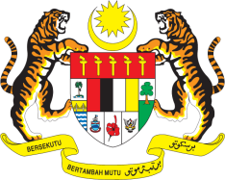

STATEMENT BY MALAYSIA
REVIEW OF GUYANA
35TH SESSION OF THE UPR WORKING GROUP
20-31 JANUARY 2020

Madam President,

Malaysia welcomes the delegation of Guyana and thanks them for the presentation of their national report.

- Malaysia takes note of Guyana’s efforts to improve institutional and policy framework to address discrimination against women and promoting gender equality, including the adoption of the national gender and social inclusion policy in 2018. We look forward to its comprehensive implementation. We are also pleased with the increased representation of women in the Cabinet.

- In the spirit of constructive engagement, my delegation recommends the following:

3.1. Implement existing laws on sexual and reproductive health; and

3.2. Revise the Health and Family Life Education to align with international guidelines in order to address sexual and gender-based violence

We wish Guyana a successful review.

I thank you Madam President.

GENEVA
29 January 2020

