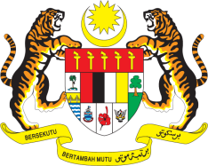

STATEMENT BY MALAYSIA
REVIEW OF TURKEY
35TH SESSION OF THE UPR WORKING GROUP
20-31 JANUARY 2020

Madam President,

Malaysia thanks Turkey for the detailed presentation of its national report.

- Malaysia takes note of the various measures undertaken by Turkey to implement recommendations from its second UPR. Malaysia lauds Turkey’s efforts to host a large number of refugees. The international community must continue to assist.

- In the spirit of constructive engagement, Malaysia recommends:

3.1. Continue promoting the rights of persons with disabilities including by harmonising its anti-discrimination legislation with the Convention on the Rights of Persons with Disabilities;
3.2. Continue upholding the rights of children including by ensuring the effective implementation of “National Program for Combating Child Labour”; and
3.3. Continue its efforts to provide education opportunities for all children, particularly those belonging to vulnerable groups.

- Malaysia wishes Turkey a successful review.

I thank you Madam President.

GENEVA
28 January 2020

