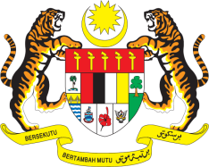

STATEMENT BY MALAYSIA
REVIEW OF SWEDEN
35TH SESSION OF THE UPR WORKING GROUP
20-31 JANUARY 2020

Madam President,

Malaysia welcomes the delegation of Sweden to this UPR session and commends the Government’s strong commitment to the promotion of human rights.

- Malaysia acknowledges Sweden’s implementation of the recommendations from its 2nd UPR, including those recommended by Malaysia. We take note of the legislative and administrative measures put in place to address contemporary forms of racism, racial discrimination, xenophobia and related intolerance. However, we are concerned with the incidences of low rate of investigations, prosecutions and convictions of perpetrators as compared to the number of reported cases of hate speech and hate crimes. In this regard, we recommend Sweden to effectively implement and enforce existing legislation and continue taking the necessary measures to protect minorities from all forms of discrimination, intolerance, racist hate speech, racist violence and other hate crimes.

- Sweden’s efforts to address gender-based violence against women are commendable. We recommend Sweden to continue undertaking proactive measures including by reinforcing assistance and protection provided to all women victims of violence.

- Finally, Malaysia recommends Sweden to accelerate efforts towards the establishment of an independent National Human Rights Institution in conformity with the Paris Principles.

Malaysia wishes Sweden a successful review.

I thank you Madam President.

GENEVA
27 January 2020

