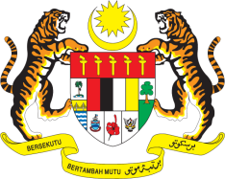

STATEMENT BY MALAYSIA
REVIEW OF SPAIN
35TH SESSION OF THE UPR WORKING GROUP
20-31 JANUARY 2020

Mr. Vice President,

Malaysia welcomes the delegation of Spain and thanks them for the presentation of their national report.

- Malaysia acknowledges Spain’s affirmative actions since its last UPR, especially in the development and implementation of national policies and programmes to further advance human rights of its people. In particular, we note improvements in Spain’s policies for the protection and advancement of women’s rights.

- In the spirit of constructive engagement, Malaysia would like to offer Spain the following recommendations:

3.1. Strengthen measures to address all forms of discrimination against minorities including by furnishing the Council for the Elimination of Racial and Ethnic Discrimination with adequate resources to enable it to execute its mandate effectively and independently;

3.2. Introduce comprehensive legislation to curb all forms of trafficking with focus on redress for victims;

3.3. Take steps to ensure minorities including migrants, have access to health-care services; and

3.4. Continue promoting the rights of persons with disabilities by ensuring inclusive education and accessibility of health-care services and facilities.

- Malaysia wishes Spain a successful review.

I thank you Mr. Vice President.

GENEVA
22 January 2020

