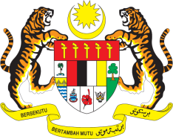

STATEMENT BY HIS EXCELLENCY DATO’ DR. AHMAD FAISAL MUHAMAD
PERMANENT REPRESENTATIVE/AMBASSADOR OF MALAYSIA TO THE UN OFFICE AND OTHER INTERNATIONAL ORGANISATIONS
REVIEW OF LAO PDR
35TH SESSION OF THE UPR WORKING GROUP
20-31 JANUARY 2020

Mr. Vice President,

Malaysia warmly welcomes the esteemed delegation of Lao People’s Democratic Republic.

- Malaysia lauds Lao PDR for its commitment to develop and improve existing laws and policies to guarantee the rights of its people. As a fellow ASEAN member, Malaysia is appreciative of Lao PDR’s contributions to the ASEAN Community building and realisation of ASEAN common human rights agenda.

- Malaysia commends Lao PDR for implementing the accepted recommendations from the previous UPRs. In the context of the current review, Malaysia offers three recommendations which we believe would further complement the undertakings of Lao PDR in promoting human rights and socio-economic developments:

3.1. Continue efforts to provide quality education for all;
3.2. Continue its effective measures to improve women’s access to health services, in particular reproductive health services; and
3.3. Strengthen regional and international cooperation in the field of human rights.

- We wish Lao PDR a successful review.

I thank you Mr. Vice President.

GENEVA
21 January 2020

