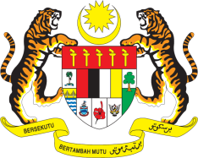

STATEMENT BY MALAYSIA
REVIEW OF KENYA
35TH SESSION OF THE UPR WORKING GROUP
20-31 JANUARY 2020

Madam Vice President,

Malaysia welcomes the delegation of Kenya and thanks them for the presentation of their national report.

- Malaysia congratulates Kenya for embracing a whole of society approach by involving government institutions, civil society and National Human Rights Institution in undertaking its 2nd UPR. We therefore welcome the National Report presented today which is a result of collaborative efforts of all stakeholders.

- Noting the progress made by Kenya in advancing human rights in the country, in line with its Vision 2030 as well as persisting challenges in certain areas, Malaysia, in the spirit of constructive engagement, recommends the following:

3.1. Take proactive and comprehensive measures to address gender-based violence including by providing victims access to remedies; and
3.2. Continue undertaking measures to ensure inclusive and quality education for all; and
3.3. Take additional measures to address lack of access to high-quality healthcare for women, including women with disabilities.

- Malaysia wishes Kenya a successful review.

I thank you Madam Vice President.

GENEVA
23 January 2020

